Exception transaction
- Credit/Debit Adjustment（Backoffice）：
Acquirers use a back ofce adjustment when a processing error is identied, usually through the reconciliation process. For instance, during reconciliation an ATM misdispense or a duplication of a transaction is discovered. Adjustment advices are entered by the acquirer’s operations staff, not by the ATM.

There are two types of adjustment transactions:
• Debit adjustments (processing code 02xxxx)—Acquirers use this transaction when an ATM dispensed more than the actual transaction amount.
• Credit adjustments (processing code 22xxxx)—Acquirers use this transaction when one of the following conditions applies:
- An ATM dispensed less than the actual amount.
- The cardholder was charged for an invalid transaction.
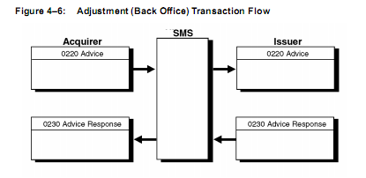
- Chargeback：
Issuers use a chargeback transaction to return a previously accepted financial transaction to an acquirer. The chargeback amount should be for the original amount and should not include optional issuer fees. Partial charge backs are allowed when the cleared amount exceeds the authorized amount.

A chargeback is distinguished from other messages of the same message type by the value of 17 in Field 25—Point-of-Service Condition Code. Reasons for chargebacks are identied in Field 63.3—Message Reason Code.

Issuers have the right to charge back to the acquirer base on the following two cases
  - Transactions are disputed by the cardholder
  - Transactions are identied as invalid by the issuer.
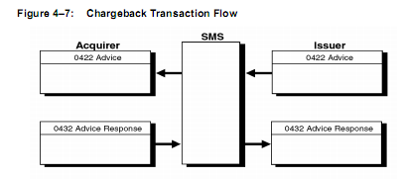
- Chargeback reversal
Chargeback reversals are used by issuers to cancel chargebacks that were sent in error to acquirers. A chargeback reversal must contain the value of 54 in Field 25—Point-of-Service Condition Code.

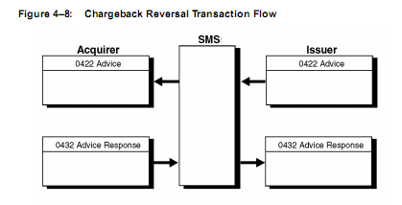
- Representment
Acquirers use representments to resubmit transactions that were charged back by issuers. An acquirer can resubmit to the issuer any item that was previously charged back by the issuer. A representment cannot be reversed or be declined.

A representment is distinguished from other messages of the same message type by a code of 13 in Field 25—Point-of-Service (POS) Condition Code. Reasons for representments are identied in Field 63.3—Message Reason Code.
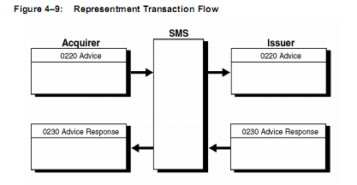

Fee-Related Transaction
- Collection Disbursement：(get fee)
Collection Disbursement can be sent by acquirer or issuer or VisaNet, Collection Disbursement do not require authorization and cannot be declined,
- Funds Disbursement ：(pay fee)
Funds Disbursement can be sent by acquirer or issuer or VisaNet, Funds Disbursement do not require authorization and cannot be declined,

Sent by acquirer：
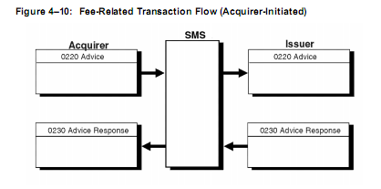
Sent by issuer：
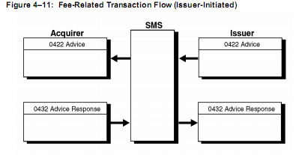

Exception Transactions Flow
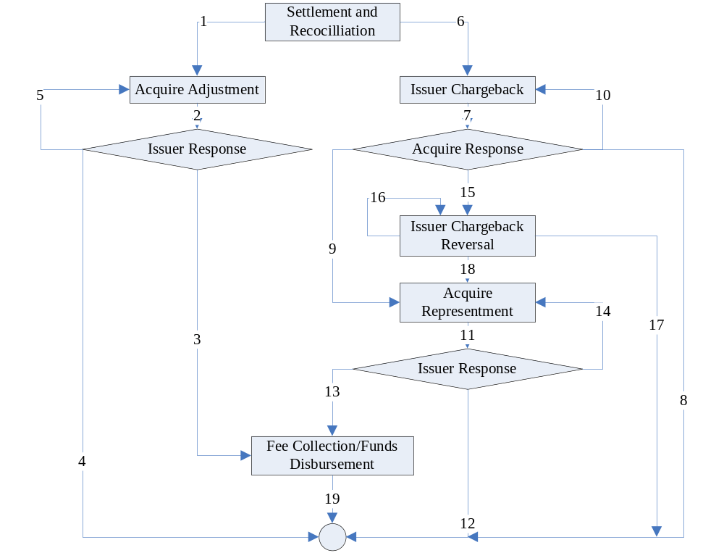
- After acquirer do settlement and Reconciliation, if find long notes or short notes, acquirer use VISA BOAS send Credit/Debit Adjustment；
- Issuer receive Credit/Debit Adjustment then response；
- If long notes or short notes problem still pending, acquirer or issuer can send Fee-Related Transaction；
- If long notes or short notes problem has been fixed, then end up flow；
- Exception：if acquirer waiting Credit/Debit Adjustment response time out, acquirer resend Credit/Debit Adjustment request；
- After issuer do settlement and Reconciliation, if the transaction that is disputed by cardholder or issuer, issuer can send Chargeback request to acquirer through VISA BOAS；
- Acquirer receive Chargeback then response；
- If acquirer agree the Chargeback, then end up flow；
- If acquirer don’t agree Chargeback, acquirer send Representment to issuer through VISA BOA；
- Exception：if issuer waiting Chargeback response time out, issuer resend Chargeback；
- Issuer receive Representment then response；
- If dispute resolution，then end up flow；
- If dispute still pending，acquirer or issuer can send Fee-Related transaction；
- Exception：if acquirer waiting Representment response time out, acquirer resend Representment request；
- When issue find out they send the wrong Chargeback transaction, issuer need send Chargeback Reversal；
- Exception：if issuer waiting Chargeback Reversal response time out, issuer resend Chargeback Reversal；
- After Chargeback Reversal success，If dispute resolution，then end up flow；
- After Chargeback Reversal success，If dispute still pending, acquirer send Representment；
- When Fee-Related transaction success, then end up flow. Notice：Fee-Related transaction is not for one transaction, it for total transactions’ total amount.

